Stratford Road, Ash Vale, Surrey GU12 5PX
E info@holly-lodge.surrey.sch.uk
www.hollylodgeprimary.co.uk
Mr S Meakin BA (Hons) Primary Education

Dear Parents/Carers,
I would like to offer you a very warm welcome to Holly Lodge Primary School, and thank you for considering us to provide the best possible education for your child. At Holly Lodge we are committed to developing and nurturing well-rounded individuals inspired to reach their full potential, and it would be an honour and privilege to welcome your child into our school community.
We are proud to be a member of the Kite Academy Trust, a group of local schools working together to ensure that your child receives the best education possible. The Kite Academy’s vision is to be a first class, collaborative and forward thinking family of local schools ensuring excellence in Primary education.
We have a wonderful team of staff and governors who are fully committed to offering your children a broad, balanced curriculum and a wide range of exciting experiences and opportunities. We want the children to enjoy coming to school, feel enthusiastic and eager to learn. Relationships are a crucial motivating force in our school; everything we achieve is down to the strong sense of teamwork that permeates all that we do.
At Holly Lodge we understand the importance of working in partnership with parents to achieve the same common goal: trying to bring up polite, confident young human beings with the academic and social skills needed to succeed in later life.
Our core purpose is teaching and learning, and we pride ourselves on the quality of teaching in our school. We have highly developed assessment, monitoring and evaluation procedures in place and a wide range of excellent resources to support learning. We pride ourselves on our sporting achievements and children are given the opportunity to participate in high quality PE lessons, clubs and workshops.
Our PTA, the Holly Lodge School Association (HLSA) run many social and fund raising events and have purchased many additional resources to further improve our facilities such as music equipment, adventure play facilities and iPads. They make a fantastic contribution to our school!
We welcome visits and hold regular open events each term to enable you to see our happy, vibrant school at work.
I hope that you find the enclosed prospectus answers all your questions, however should you require further information please do not hesitate to contact me.
Yours sincerely,
Mr S Meakin, Head Teacher

Holly Lodge Primary School is part of the Kite Academy Trust a charitable company limited by guarantee and registered in England and
Wales with company number 09785186. Chief Executive Officer: Mrs C Dickinson
The registered office is Holly Lodge Primary School, Stratford Road, Ash Vale, GU12 5PX
Email: info@thekiteacademytrust.org Web: www.thekiteacademytrust.org

Introducing Our School
We are a two-form entry primary school set in beautiful grounds with excellent resources. The two Reception classes have their own designated outdoor area. All classes have access to a large hall where we hold our school assemblies, take part in P.E and run after school clubs.

Within the school we have an ICT suite which has 15 PCs. All teaching rooms in the school are equipped with interactive whiteboards. We also have a class set of iPads which we use to enhance learning. We have a fantastic self-contained library which is well-stocked with a variety of books and resources.

The school grounds are very well maintained and include three designated adventure play areas and three tarmac playgrounds. With a large playing field for team sports and numerous natural shaded areas, we are very grateful to be able to offer wonderful outdoor learning opportunities across the whole school.

School meals are freshly prepared onsite each day by the Surrey Catering team. They pride themselves in offering delicious, healthy lunches. Pupils are offered a choice of three meal options each day. Currently lunches are free for all Infant pupils.

Early Years Provision
At Holly Lodge we have a team of highly experienced Early Years staff. All activities are planned by analysing the children’s needs and interests to make the learning purposeful and meaningful to them.

In our early years classes the learning is child-led, creative, fun and challenging. We have a rich and stimulating learning environment, which motivates and inspires children to develop and learn effectively. Our excellent, well-resourced outside classroom allows children to learn on a large scale and construct, explore and develop their physical skills.

Play is essential for learning and development, and so we ensure that children can initiate their own learning through play with children across both classes. We recognise that children have different starting points and learning styles and therefore tailor our learning to benefit all children through play, exploration and their ideas.

Learning is interactive using our Smartboards and iPads, and is often outside taking full advantage of the fantastic learning spaces we have around school. Focussed activities are also carefully planned, and led by teachers. This is to ensure that children’s next steps can be met, and that children are challenged to encourage progress and development.

At Holly Lodge, the Early Years team pride themselves by giving the children an excellent start to their school life and ensure they receive a smooth transition to their next stage of learning. Our team is comprised of two class teachers supported by two Teaching Assistants and an additional Interventions Teaching Assistant who is there to assist pupils who may need extra help.

Admissions to Foundation Stage
Statutory school age admissions are managed centrally by Surrey County Council. Further details can be obtained by contacting Surrey school admissions on 0300 200 1004. Information on how to apply online is available at
www.surreycc.gov.uk/schools-and-learning/schools/school-admissions.

Phased entry
In order to ensure a smooth transition into school, children will engage in a phased entry programme. All children start school on the same day. Depending on their birthday, children will be invited to stay full time from a date within a two-week period. Up until this point they will finish at 12pm. Phased entry allows the school to offer a higher staff ratio to assist the children in settling in. The sessions will be class based, giving children the opportunity to get to know their class group before the free-flow system begins in the third week.

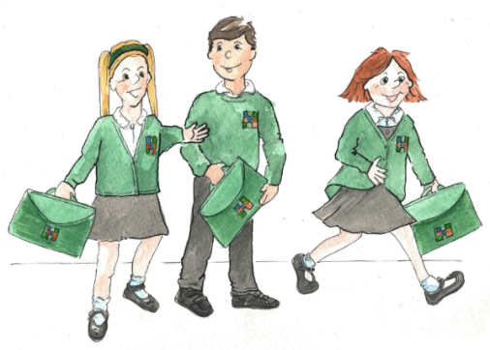
Life After Reception…
As the children move up through Holly Lodge, we continue to provide them with a wealth of opportunities to grow and develop, through well-planned and executed lessons as well as appropriate and effective interventions. We also offer engaging and purposeful sports programmes, relevant and interesting trips and residential visits. Children are always encouraged to reach their full potential.

From their first days with us at Holly Lodge, right through until they leave for secondary school, your child will have the support, guidance, and learning opportunities that they need to thrive.

School Timings
8.40 a.m. | First bell rings. Pupils in Years 1 - 6 are welcome to come into the classroom to get ready for the day, or they may stay on the playground until the second bell.  Pupils in Year R stay on the playground with parents until the second bell.
8.50 a.m. | Second bell rings. Pupils in Years 1 - 6 must come into the classroom (if they haven’t already done so) for registration.  Pupils in Year R will be collected by their teachers and taken into the classroom.
10.30 – 10.45 a.m. | Break
12.00 – 1.15 p.m. | Lunch
3.15 p.m. | Final bell signals the end of end of School day

School gates are open from 8.30am. Staff will be supervising the playground from 8.40am for Juniors. Parents of Infant pupils are expected to stay with their children until they go into the classroom.

Breakfast and After School Club
At Holly Lodge we can provide a package of wrap-around care. This includes an after school club and a breakfast club. Staffed by external providers, these clubs mirror the school’s ethos and values, and provide an environment where children are nurtures and can further develop what they learn during the core school hours. Allowing working parents to drop their child off from 7.30am and collect up until 6pm we feel we are doing our best support our working families.

Lunchtimes and Drinks
Every morning, children choose from a menu of choices allowing you total flexibility on whether your child has a cooked meal that day. There is a main meat based choice, a vegetarian option and a jacket potato each day, or you may bring a packed lunch from home. Water is freely available in the lunch hall and from fountains. The rotating three-week menu is published in advance allowing you to plan your evening meals accordingly, should you wish to.

Online Access
Conscious of the pressures on modern parents, we have invested in a number of options to allow you to manage your child’s school activities online. We are a cashless school and all payments for trips and lunches are made via our online payment portal. Additionally, you may book parents evening appointments and places on teacher-run after school clubs via our online booking system.
Our primary means of communication is via email with a wealth of up to date information available on our school website. You can synchronize your personal diary with our online calendar to ensure that you have all of the key dates for the year. Our school newsletter is emailed regularly and will keep you up to date with exciting news and key information.

School Uniform
We believe that high standards of uniform are an expression of pride in our school and ask parents to support us to ensure their children are dressed appropriately. All pupils are expected to wear full school uniform. School sweatshirts, cardigans, coats and bags may be purchased at either of our suppliers, Tesco or Brenda’s in Frimley. All other items may be bought from normal school uniform suppliers. Full details of the items to wear can be found on the school website under the New Parents section. Our HLSA also run a recycled uniform shop allowing you to purchase uniform items at a reduced cost.

Health & Wellbeing
The majority of staff are trained First Aiders and are always available during school hours. We are able to administer asthma medication and epi-pens where appropriate, and have a defibrillator on site. Please note we are unable to administer medicines that have not been prescribed by a doctor.

We also have a Family Support Worker who is able to offer guidance to families with any issues that may be affecting them. Whether through parenting courses, access to adult learning opportunities or with support where English is an additional language.

We are also very fortunate to have a team of Emotional Literacy Support Assistants here at school. The role of the ELSA is to work with any children who may need extra reassurance, support or guidance with any issues within school or outside. Children work with their ELSA in a purpose built sensory room to discuss any worries or fears and find solutions to empower them to overcome their difficulty.

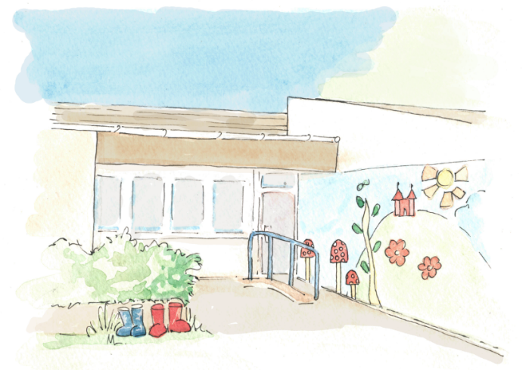
Keeping your Child Safe
At Holly Lodge your child’s safety is a priority, and the staff and Governors rigorously review safety procedures to ensure policies and safeguards are in place to protect and promote the welfare of children and staff. All our staff members are DBS checked and receive Safeguarding training when they join the school.

Security on site is strict, with all visitors reporting via the front office. All staff are vigilant and will question anyone who is not wearing a school-issued ID badge on our premises. Access during the school day is only via our front gate which has security cameras and an intercom system.

We have various measures in place for any concerns relating to pupils that may arise. Our designated Child Protection Liaison Officers are contactable if you have any concerns relating to pupils.

Anti-Bullying Procedures
Holly Lodge will challenge all forms of bullying to improve the safety and happiness of its pupils and makes it clear to bullies that anti-social behaviour is totally unacceptable. We pride ourselves on the behaviour of our children, and in our last OFSTED behaviour was rated as Outstanding. Our Behaviour Policy is fully embedded, and is available to on our website along with our Anti-Bullying Policy. We believe in shining the light on the good, noticing and rewarding good behaviour.

Special Educational Needs
We will identify pupils with additional needs and ensure that we offer a suitable learning and support for them. Our Inclusion Manager oversees this provision and our team of teaching assistants work alongside the teachers to provide individual and small group support. If necessary, we seek further advice from outside agencies.

Pupils with Disabilities
The school makes every effort to ensure that disabled pupils receive equal opportunity. The school’s Access Plan, in response to the Disabilities Act 2002, was put into place in September 2009. There is disabled car parking and access to all areas of the building. We also have suitable toilet and shower facilities.

School Vision and Values
Vision:

“Together, we can achieve more.”

Our vision underpins all that we do. By working together with parents, carers and the local community we believe we have much to offer.
Values:

- Respect
- Effort
- Achieve
- Care
- Honest

We expect and encourage all our pupils to demonstrate our “REACH” values throughout their time at Holly Lodge.

Ofsted
Our most recent Ofsted inspection took place in March 2013. The school is rated as Good, however we constantly strive towards being Outstanding. Further information on their inspection can be found on the Ofsted website.

Disability Equality Statement
At Holly Lodge School, we are committed to equality of opportunity in line with the Equality Act of October 2010. We shall endeavour to make a positive contribution to society by demonstrating qualities such as respect, co-operation and valuing differences while celebrating cultural diversity. This commitment applies to our work in the classroom, our pupil support systems, our recruitment and retention of staff and our work in the local and wider community.

